**Name : Md Abdur Rahman**

**ID : 213-15-4343**

**SEC : 60_D**

**CPU SCHEDULING (CODE WITH INPUT AND OUTPUT)**

**1.First Come First Serve(FCFS):**

**CODE:**

#include <bits/stdc++.h>

using namespace std;

struct process {

int pid;

int arrival_time;

int burst_time;

int start_time;

int completion_time;

int turnaround_time;

int waiting_time;

int response_time;

};

bool compareArrival(process p1, process p2)

{

return p1.arrival_time < p2.arrival_time;

}

bool compareID(process p1, process p2)

{

return p1.pid < p2.pid;

}

int main() {

int n;

struct process p[100];

float avg_turnaround_time;

float avg_waiting_time;

float avg_response_time;

float cpu_utilisation;

int total_turnaround_time = 0;

int total_waiting_time = 0;

int total_response_time = 0;

int total_idle_time = 0;

float throughput;

cout << setprecision(2) << fixed;

cout<<"Enter the number of processes: ";

cin>>n;

for(int i = 0; i < n; i++) {

cout<<"Enter arrival time of process "<<i+1<<": ";

cin>>p[i].arrival_time;

cout<<"Enter burst time of process "<<i+1<<": ";

cin>>p[i].burst_time;

p[i].pid = i+1;

cout<<endl;

}

sort(p,p+n,compareArrival);

for(int i = 0; i < n; i++) {

p[i].start_time = (i == 0)?p[i].arrival_time:max(p[i-1].completion_time,p[i].arrival_time);

p[i].completion_time = p[i].start_time + p[i].burst_time;

p[i].turnaround_time = p[i].completion_time - p[i].arrival_time;

p[i].waiting_time = p[i].turnaround_time - p[i].burst_time;

p[i].response_time = p[i].start_time - p[i].arrival_time;

total_turnaround_time += p[i].turnaround_time;

total_waiting_time += p[i].waiting_time;

total_response_time += p[i].response_time;

total_idle_time += (i == 0)?(p[i].arrival_time):(p[i].start_time - p[i-1].completion_time);

}

avg_turnaround_time = (float) total_turnaround_time / n;

avg_waiting_time = (float) total_waiting_time / n;

avg_response_time = (float) total_response_time / n;

throughput = float(n) / (p[n-1].completion_time - p[0].arrival_time);

sort(p,p+n,compareID);

cout<<endl;

cout<<"#P\t"<<"AT\t"<<"BT\t"<<"ST\t"<<"CT\t"<<"TAT\t"<<"WT\t"<<"RT\t"<<"\n"<<endl;

for(int i = 0; i < n; i++) {

cout<<p[i].pid<<"\t"<<p[i].arrival_time<<"\t"<<p[i].burst_time<<"\t"<<p[i].start_time<<"\t"<<p[i].completion_time<<"\t"<<p[i].turnaround_time<<"\t"<<p[i].waiting_time<<"\t"<<p[i].response_time<<"\t"<<"\n"<<endl;

}

cout<<"Average Turnaround Time = "<<avg_turnaround_time<<endl;

cout<<"Average Waiting Time = "<<avg_waiting_time<<endl;

cout<<"Average Response Time = "<<avg_response_time<<endl;

cout<<"Throughput = "<<throughput<<" process/unit time"<<endl;

}

/*

AT - Arrival Time of the process

BT - Burst time of the process

ST - Start time of the process

CT - Completion time of the process

TAT - Turnaround time of the process

WT - Waiting time of the process

RT - Response time of the process

Formulas used:

TAT = CT - AT

WT = TAT - BT

RT = ST - AT

*/

**INPUT AND OUTPUT:**

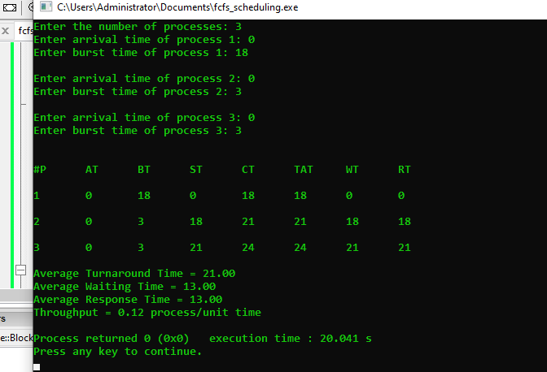

**2.Shortest Job First Premitive (SJF):**

#include <bits/stdc++.h>

using namespace std;

struct process {

int pid;

int arrival_time;

int burst_time;

int start_time;

int completion_time;

int turnaround_time;

int waiting_time;

int response_time;

};

int main() {

int n;

struct process p[100];

float avg_turnaround_time;

float avg_waiting_time;

float avg_response_time;

float cpu_utilisation;

int total_turnaround_time = 0;

int total_waiting_time = 0;

int total_response_time = 0;

int total_idle_time = 0;

float throughput;

int burst_remaining[100];

int is_completed[100];

memset(is_completed,0,sizeof(is_completed));

cout << setprecision(2) << fixed;

cout<<"Enter the number of processes: ";

cin>>n;

for(int i = 0; i < n; i++) {

cout<<"Enter arrival time of process "<<i+1<<": ";

cin>>p[i].arrival_time;

cout<<"Enter burst time of process "<<i+1<<": ";

cin>>p[i].burst_time;

p[i].pid = i+1;

burst_remaining[i] = p[i].burst_time;

cout<<endl;

}

int current_time = 0;

int completed = 0;

int prev = 0;

while(completed != n) {

int idx = -1;

int mn = 10000000;

for(int i = 0; i < n; i++) {

if(p[i].arrival_time <= current_time && is_completed[i] == 0) {

if(burst_remaining[i] < mn) {

mn = burst_remaining[i];

idx = i;

}

if(burst_remaining[i] == mn) {

if(p[i].arrival_time < p[idx].arrival_time) {

mn = burst_remaining[i];

idx = i;

}

}

}

}

if(idx != -1) {

if(burst_remaining[idx] == p[idx].burst_time) {

p[idx].start_time = current_time;

total_idle_time += p[idx].start_time - prev;

}

burst_remaining[idx] -= 1;

current_time++;

prev = current_time;

if(burst_remaining[idx] == 0) {

p[idx].completion_time = current_time;

p[idx].turnaround_time = p[idx].completion_time - p[idx].arrival_time;

p[idx].waiting_time = p[idx].turnaround_time - p[idx].burst_time;

p[idx].response_time = p[idx].start_time - p[idx].arrival_time;

total_turnaround_time += p[idx].turnaround_time;

total_waiting_time += p[idx].waiting_time;

total_response_time += p[idx].response_time;

is_completed[idx] = 1;

completed++;

}

}

else {

current_time++;

}

}

int min_arrival_time = 10000000;

int max_completion_time = -1;

for(int i = 0; i < n; i++) {

min_arrival_time = min(min_arrival_time,p[i].arrival_time);

max_completion_time = max(max_completion_time,p[i].completion_time);

}

avg_turnaround_time = (float) total_turnaround_time / n;

avg_waiting_time = (float) total_waiting_time / n;

avg_response_time = (float) total_response_time / n;

cpu_utilisation = ((max_completion_time - total_idle_time) / (float) max_completion_time )*100;

throughput = float(n) / (max_completion_time - min_arrival_time);

cout<<endl<<endl;

cout<<"#P\t"<<"AT\t"<<"BT\t"<<"ST\t"<<"CT\t"<<"TAT\t"<<"WT\t"<<"RT\t"<<"\n"<<endl;

for(int i = 0; i < n; i++) {

cout<<p[i].pid<<"\t"<<p[i].arrival_time<<"\t"<<p[i].burst_time<<"\t"<<p[i].start_time<<"\t"<<p[i].completion_time<<"\t"<<p[i].turnaround_time<<"\t"<<p[i].waiting_time<<"\t"<<p[i].response_time<<"\t"<<"\n"<<endl;

}

cout<<"Average Turnaround Time = "<<avg_turnaround_time<<endl;

cout<<"Average Waiting Time = "<<avg_waiting_time<<endl;

cout<<"Average Response Time = "<<avg_response_time<<endl;

cout<<"CPU Utilization = "<<cpu_utilisation<<"%"<<endl;

cout<<"Throughput = "<<throughput<<" process/unit time"<<endl;

}

/*

AT - Arrival Time of the process

BT - Burst time of the process

ST - Start time of the process

CT - Completion time of the process

TAT - Turnaround time of the process

WT - Waiting time of the process

RT - Response time of the process

Formulas used:

TAT = CT - AT

WT = TAT - BT

RT = ST - AT

*/

**INPUT AND OUTPUT:**

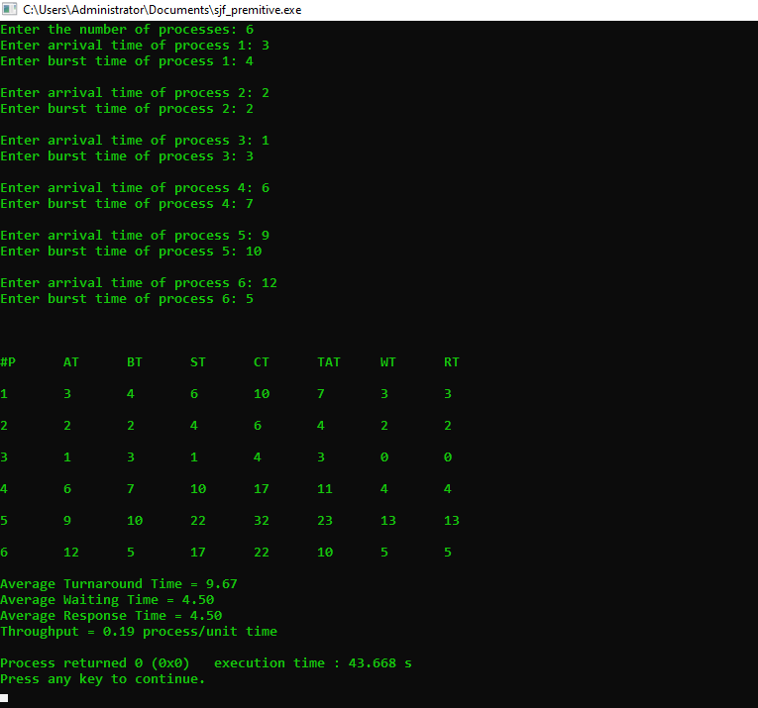

**3.Shortest Job First Nonpremitive (SJF):**

#include <bits/stdc++.h>

using namespace std;

struct process {

int pid;

int arrival_time;

int burst_time;

int start_time;

int completion_time;

int turnaround_time;

int waiting_time;

int response_time;

};

int main() {

int n;

struct process p[100];

float avg_turnaround_time;

float avg_waiting_time;

float avg_response_time;

float cpu_utilisation;

int total_turnaround_time = 0;

int total_waiting_time = 0;

int total_response_time = 0;

int total_idle_time = 0;

float throughput;

int is_completed[100];

memset(is_completed,0,sizeof(is_completed));

cout << setprecision(2) << fixed;

cout<<"Enter the number of processes: ";

cin>>n;

for(int i = 0; i < n; i++) {

cout<<"Enter arrival time of process "<<i+1<<": ";

cin>>p[i].arrival_time;

cout<<"Enter burst time of process "<<i+1<<": ";

cin>>p[i].burst_time;

p[i].pid = i+1;

cout<<endl;

}

int current_time = 0;

int completed = 0;

int prev = 0;

while(completed != n) {

int idx = -1;

int mn = 10000000;

for(int i = 0; i < n; i++) {

if(p[i].arrival_time <= current_time && is_completed[i] == 0) {

if(p[i].burst_time < mn) {

mn = p[i].burst_time;

idx = i;

}

if(p[i].burst_time == mn) {

if(p[i].arrival_time < p[idx].arrival_time) {

mn = p[i].burst_time;

idx = i;

}

}

}

}

if(idx != -1) {

p[idx].start_time = current_time;

p[idx].completion_time = p[idx].start_time + p[idx].burst_time;

p[idx].turnaround_time = p[idx].completion_time - p[idx].arrival_time;

p[idx].waiting_time = p[idx].turnaround_time - p[idx].burst_time;

p[idx].response_time = p[idx].start_time - p[idx].arrival_time;

total_turnaround_time += p[idx].turnaround_time;

total_waiting_time += p[idx].waiting_time;

total_response_time += p[idx].response_time;

total_idle_time += p[idx].start_time - prev;

is_completed[idx] = 1;

completed++;

current_time = p[idx].completion_time;

prev = current_time;

}

else {

current_time++;

}

}

int min_arrival_time = 10000000;

int max_completion_time = -1;

for(int i = 0; i < n; i++) {

min_arrival_time = min(min_arrival_time,p[i].arrival_time);

max_completion_time = max(max_completion_time,p[i].completion_time);

}

avg_turnaround_time = (float) total_turnaround_time / n;

avg_waiting_time = (float) total_waiting_time / n;

avg_response_time = (float) total_response_time / n;

cpu_utilisation = ((max_completion_time - total_idle_time) / (float) max_completion_time )*100;

throughput = float(n) / (max_completion_time - min_arrival_time);

cout<<endl<<endl;

cout<<"#P\t"<<"AT\t"<<"BT\t"<<"ST\t"<<"CT\t"<<"TAT\t"<<"WT\t"<<"RT\t"<<"\n"<<endl;

for(int i = 0; i < n; i++) {

cout<<p[i].pid<<"\t"<<p[i].arrival_time<<"\t"<<p[i].burst_time<<"\t"<<p[i].start_time<<"\t"<<p[i].completion_time<<"\t"<<p[i].turnaround_time<<"\t"<<p[i].waiting_time<<"\t"<<p[i].response_time<<"\t"<<"\n"<<endl;

}

cout<<"Average Turnaround Time = "<<avg_turnaround_time<<endl;

cout<<"Average Waiting Time = "<<avg_waiting_time<<endl;

cout<<"Average Response Time = "<<avg_response_time<<endl;

cout<<"Throughput = "<<throughput<<" process/unit time"<<endl;

}

/*

AT - Arrival Time of the process

BT - Burst time of the process

ST - Start time of the process

CT - Completion time of the process

TAT - Turnaround time of the process

WT - Waiting time of the process

RT - Response time of the process

Formulas used:

TAT = CT - AT

WT = TAT - BT

RT = ST - AT

*/

**INPUT AND OUTPUT:**

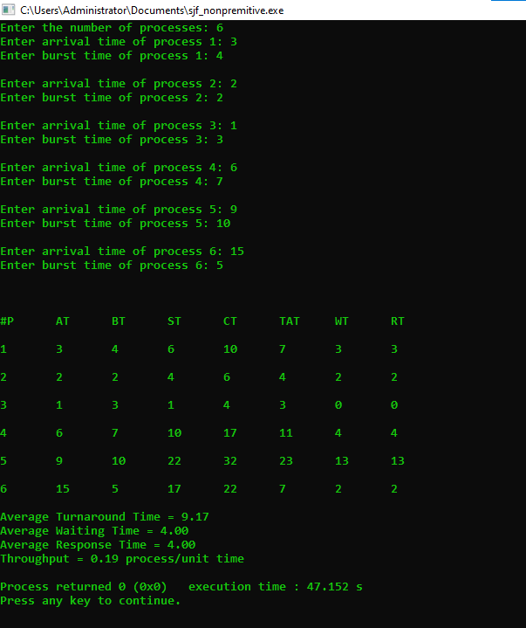

**4. Nonpremitive Priority Scheduling:**

#include <bits/stdc++.h>

using namespace std;

struct process {

int pid;

int arrival_time;

int burst_time;

int priority;

int start_time;

int completion_time;

int turnaround_time;

int waiting_time;

int response_time;

};

int main() {

int n;

struct process p[100];

float avg_turnaround_time;

float avg_waiting_time;

float avg_response_time;

float cpu_utilisation;

int total_turnaround_time = 0;

int total_waiting_time = 0;

int total_response_time = 0;

int total_idle_time = 0;

float throughput;

int is_completed[100];

memset(is_completed,0,sizeof(is_completed));

cout << setprecision(2) << fixed;

cout<<"Enter the number of processes: ";

cin>>n;

for(int i = 0; i < n; i++) {

cout<<"Enter arrival time of process "<<i+1<<": ";

cin>>p[i].arrival_time;

cout<<"Enter burst time of process "<<i+1<<": ";

cin>>p[i].burst_time;

cout<<"Enter priority of the process "<<i+1<<": ";

cin>>p[i].priority;

p[i].pid = i+1;

cout<<endl;

}

int current_time = 0;

int completed = 0;

int prev = 0;

while(completed != n) {

int idx = -1;

int mx = -1;

for(int i = 0; i < n; i++) {

if(p[i].arrival_time <= current_time && is_completed[i] == 0) {

if(p[i].priority > mx) {

mx = p[i].priority;

idx = i;

}

if(p[i].priority == mx) {

if(p[i].arrival_time < p[idx].arrival_time) {

mx = p[i].priority;

idx = i;

}

}

}

}

if(idx != -1) {

p[idx].start_time = current_time;

p[idx].completion_time = p[idx].start_time + p[idx].burst_time;

p[idx].turnaround_time = p[idx].completion_time - p[idx].arrival_time;

p[idx].waiting_time = p[idx].turnaround_time - p[idx].burst_time;

p[idx].response_time = p[idx].start_time - p[idx].arrival_time;

total_turnaround_time += p[idx].turnaround_time;

total_waiting_time += p[idx].waiting_time;

total_response_time += p[idx].response_time;

total_idle_time += p[idx].start_time - prev;

is_completed[idx] = 1;

completed++;

current_time = p[idx].completion_time;

prev = current_time;

}

else {

current_time++;

}

}

int min_arrival_time = 10000000;

int max_completion_time = -1;

for(int i = 0; i < n; i++) {

min_arrival_time = min(min_arrival_time,p[i].arrival_time);

max_completion_time = max(max_completion_time,p[i].completion_time);

}

avg_turnaround_time = (float) total_turnaround_time / n;

avg_waiting_time = (float) total_waiting_time / n;

avg_response_time = (float) total_response_time / n;

throughput = float(n) / (max_completion_time - min_arrival_time);

cout<<endl<<endl;

cout<<"#P\t"<<"AT\t"<<"BT\t"<<"PRI\t"<<"ST\t"<<"CT\t"<<"TAT\t"<<"WT\t"<<"RT\t"<<"\n"<<endl;

for(int i = 0; i < n; i++) {

cout<<p[i].pid<<"\t"<<p[i].arrival_time<<"\t"<<p[i].burst_time<<"\t"<<p[i].priority<<"\t"<<p[i].start_time<<"\t"<<p[i].completion_time<<"\t"<<p[i].turnaround_time<<"\t"<<p[i].waiting_time<<"\t"<<p[i].response_time<<"\t"<<"\n"<<endl;

}

cout<<"Average Turnaround Time = "<<avg_turnaround_time<<endl;

cout<<"Average Waiting Time = "<<avg_waiting_time<<endl;

cout<<"Average Response Time = "<<avg_response_time<<endl;

cout<<"Throughput = "<<throughput<<" process/unit time"<<endl;

}

/*

AT - Arrival Time of the process

BT - Burst time of the process

ST - Start time of the process

CT - Completion time of the process

TAT - Turnaround time of the process

WT - Waiting time of the process

RT - Response time of the process

Formulas used:

TAT = CT - AT

WT = TAT - BT

RT = ST - AT

*/

**INPUT AND OUTPUT:**

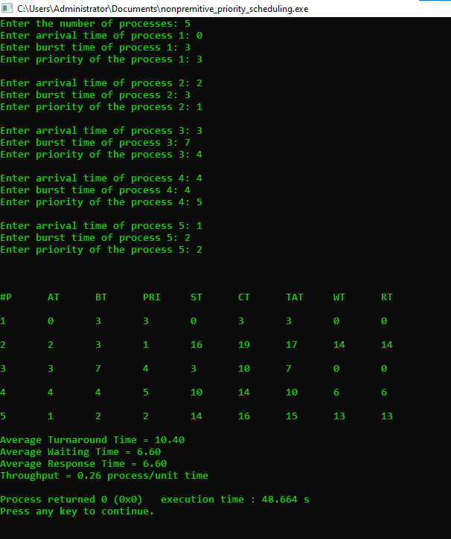

**5. Premitive Priority Scheduling:**

#include <bits/stdc++.h>

using namespace std;

struct process {

int pid;

int arrival_time;

int burst_time;

int priority;

int start_time;

int completion_time;

int turnaround_time;

int waiting_time;

int response_time;

};

int main() {

int n;

struct process p[100];

float avg_turnaround_time;

float avg_waiting_time;

float avg_response_time;

float cpu_utilisation;

int total_turnaround_time = 0;

int total_waiting_time = 0;

int total_response_time = 0;

int total_idle_time = 0;

float throughput;

int burst_remaining[100];

int is_completed[100];

memset(is_completed,0,sizeof(is_completed));

cout << setprecision(2) << fixed;

cout<<"Enter the number of processes: ";

cin>>n;

for(int i = 0; i < n; i++) {

cout<<"Enter arrival time of process "<<i+1<<": ";

cin>>p[i].arrival_time;

cout<<"Enter burst time of process "<<i+1<<": ";

cin>>p[i].burst_time;

cout<<"Enter priority of the process "<<i+1<<": ";

cin>>p[i].priority;

p[i].pid = i+1;

burst_remaining[i] = p[i].burst_time;

cout<<endl;

}

int current_time = 0;

int completed = 0;

int prev = 0;

while(completed != n) {

int idx = -1;

int mx = -1;

for(int i = 0; i < n; i++) {

if(p[i].arrival_time <= current_time && is_completed[i] == 0) {

if(p[i].priority > mx) {

mx = p[i].priority;

idx = i;

}

if(p[i].priority == mx) {

if(p[i].arrival_time < p[idx].arrival_time) {

mx = p[i].priority;

idx = i;

}

}

}

}

if(idx != -1) {

if(burst_remaining[idx] == p[idx].burst_time) {

p[idx].start_time = current_time;

total_idle_time += p[idx].start_time - prev;

}

burst_remaining[idx] -= 1;

current_time++;

prev = current_time;

if(burst_remaining[idx] == 0) {

p[idx].completion_time = current_time;

p[idx].turnaround_time = p[idx].completion_time - p[idx].arrival_time;

p[idx].waiting_time = p[idx].turnaround_time - p[idx].burst_time;

p[idx].response_time = p[idx].start_time - p[idx].arrival_time;

total_turnaround_time += p[idx].turnaround_time;

total_waiting_time += p[idx].waiting_time;

total_response_time += p[idx].response_time;

is_completed[idx] = 1;

completed++;

}

}

else {

current_time++;

}

}

int min_arrival_time = 10000000;

int max_completion_time = -1;

for(int i = 0; i < n; i++) {

min_arrival_time = min(min_arrival_time,p[i].arrival_time);

max_completion_time = max(max_completion_time,p[i].completion_time);

}

avg_turnaround_time = (float) total_turnaround_time / n;

avg_waiting_time = (float) total_waiting_time / n;

avg_response_time = (float) total_response_time / n;

throughput = float(n) / (max_completion_time - min_arrival_time);

cout<<endl<<endl;

cout<<"#P\t"<<"AT\t"<<"BT\t"<<"PRI\t"<<"ST\t"<<"CT\t"<<"TAT\t"<<"WT\t"<<"RT\t"<<"\n"<<endl;

for(int i = 0; i < n; i++) {

cout<<p[i].pid<<"\t"<<p[i].arrival_time<<"\t"<<p[i].burst_time<<"\t"<<p[i].priority<<"\t"<<p[i].start_time<<"\t"<<p[i].completion_time<<"\t"<<p[i].turnaround_time<<"\t"<<p[i].waiting_time<<"\t"<<p[i].response_time<<"\t"<<"\n"<<endl;

}

cout<<"Average Turnaround Time = "<<avg_turnaround_time<<endl;

cout<<"Average Waiting Time = "<<avg_waiting_time<<endl;

cout<<"Average Response Time = "<<avg_response_time<<endl;

cout<<"Throughput = "<<throughput<<" process/unit time"<<endl;

}

/*

AT - Arrival Time of the process

BT - Burst time of the process

ST - Start time of the process

CT - Completion time of the process

TAT - Turnaround time of the process

WT - Waiting time of the process

RT - Response time of the process

Formulas used:

TAT = CT - AT

WT = TAT - BT

RT = ST - AT

*/

**INPUT AND OUTPUT:**

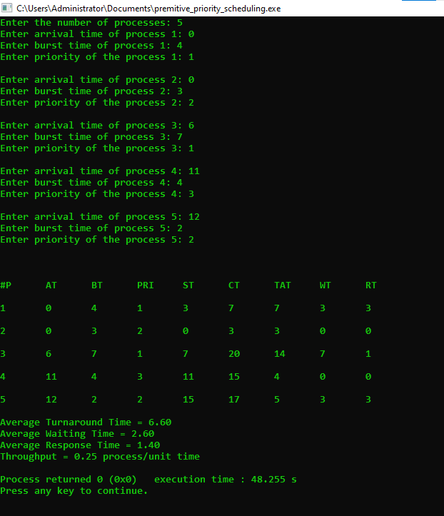

**6. Round Robin Scheduling:**

#include <bits/stdc++.h>

using namespace std;

struct process {

int pid;

int arrival_time;

int burst_time;

int start_time;

int completion_time;

int turnaround_time;

int waiting_time;

int response_time;

};

bool compare1(process p1, process p2)

{

return p1.arrival_time < p2.arrival_time;

}

bool compare2(process p1, process p2)

{

return p1.pid < p2.pid;

}

int main() {

int n;

int tq;

struct process p[100];

float avg_turnaround_time;

float avg_waiting_time;

float avg_response_time;

float cpu_utilisation;

int total_turnaround_time = 0;

int total_waiting_time = 0;

int total_response_time = 0;

int total_idle_time = 0;

float throughput;

int burst_remaining[100];

int idx;

cout << setprecision(2) << fixed;

cout<<"Enter the number of processes: ";

cin>>n;

cout<<"Enter time quantum: ";

cin>>tq;

for(int i = 0; i < n; i++) {

cout<<"Enter arrival time of process "<<i+1<<": ";

cin>>p[i].arrival_time;

cout<<"Enter burst time of process "<<i+1<<": ";

cin>>p[i].burst_time;

burst_remaining[i] = p[i].burst_time;

p[i].pid = i+1;

cout<<endl;

}

sort(p,p+n,compare1);

queue<int> q;

int current_time = 0;

q.push(0);

int completed = 0;

int mark[100];

memset(mark,0,sizeof(mark));

mark[0] = 1;

while(completed != n) {

idx = q.front();

q.pop();

if(burst_remaining[idx] == p[idx].burst_time) {

p[idx].start_time = max(current_time,p[idx].arrival_time);

total_idle_time += p[idx].start_time - current_time;

current_time = p[idx].start_time;

}

if(burst_remaining[idx]-tq > 0) {

burst_remaining[idx] -= tq;

current_time += tq;

}

else {

current_time += burst_remaining[idx];

burst_remaining[idx] = 0;

completed++;

p[idx].completion_time = current_time;

p[idx].turnaround_time = p[idx].completion_time - p[idx].arrival_time;

p[idx].waiting_time = p[idx].turnaround_time - p[idx].burst_time;

p[idx].response_time = p[idx].start_time - p[idx].arrival_time;

total_turnaround_time += p[idx].turnaround_time;

total_waiting_time += p[idx].waiting_time;

total_response_time += p[idx].response_time;

}

for(int i = 1; i < n; i++) {

if(burst_remaining[i] > 0 && p[i].arrival_time <= current_time && mark[i] == 0) {

q.push(i);

mark[i] = 1;

}

}

if(burst_remaining[idx] > 0) {

q.push(idx);

}

if(q.empty()) {

for(int i = 1; i < n; i++) {

if(burst_remaining[i] > 0) {

q.push(i);

mark[i] = 1;

break;

}

}

}

}

avg_turnaround_time = (float) total_turnaround_time / n;

avg_waiting_time = (float) total_waiting_time / n;

avg_response_time = (float) total_response_time / n;

throughput = float(n) / (p[n-1].completion_time - p[0].arrival_time);

sort(p,p+n,compare2);

cout<<endl;

cout<<"#P\t"<<"AT\t"<<"BT\t"<<"ST\t"<<"CT\t"<<"TAT\t"<<"WT\t"<<"RT\t"<<"\n"<<endl;

for(int i = 0; i < n; i++) {

cout<<p[i].pid<<"\t"<<p[i].arrival_time<<"\t"<<p[i].burst_time<<"\t"<<p[i].start_time<<"\t"<<p[i].completion_time<<"\t"<<p[i].turnaround_time<<"\t"<<p[i].waiting_time<<"\t"<<p[i].response_time<<"\t"<<"\n"<<endl;

}

cout<<"Average Turnaround Time = "<<avg_turnaround_time<<endl;

cout<<"Average Waiting Time = "<<avg_waiting_time<<endl;

cout<<"Average Response Time = "<<avg_response_time<<endl;

cout<<"Throughput = "<<throughput<<" process/unit time"<<endl;

}

/*

AT - Arrival Time of the process

BT - Burst time of the process

ST - Start time of the process

CT - Completion time of the process

TAT - Turnaround time of the process

WT - Waiting time of the process

RT - Response time of the process

Formulas used:

TAT = CT - AT

WT = TAT - BT

RT = ST - AT

*/

**INPUT AND OUTPUT:**

